create database crud;
show databases;
use crud;
CREATE TABLE `user` (
`sl_no` INT(5) NULL DEFAULT NULL,
`name` VARCHAR(100) NULL DEFAULT NULL,
`email` VARCHAR(100) NULL DEFAULT NULL
)
COLLATE='latin1_swedish_ci'
ENGINE=InnoDB;

select* from user;

Crud_Test.java

package crud_operations;
import java.sql.Connection;
import java.sql.PreparedStatement;
import java.sql.ResultSet;

public class Crud_Test {

public static void main(String[] args) {

Crud_Test obj = new Crud_Test();

// CREATE
obj.create_data(101, "Arun", "arun@gmail.com");

// READ
obj.read_data(101);

// UPDATE
obj.update_data(101, "Arun Kumar", "arunkumar@gmail.com");

// READ AGAIN
obj.read_data(101);

// DELETE
obj.delete_data(101);
}

public void create_data(int sl_no, String name, String email) {

try {

DB_Connection db = new DB_Connection();
Connection con = db.get_connection();

String query =
"INSERT INTO user(sl_no,name,email) VALUES(?,?,?)";

PreparedStatement ps =
con.prepareStatement(query);

ps.setInt(1, sl_no);
ps.setString(2, name);
ps.setString(3, email);

int count = ps.executeUpdate();

if(count > 0)
System.out.println("Data Inserted Successfully");

} catch(Exception e) {
System.out.println(e);
}
}

public void read_data(int sl_no) {

try {

DB_Connection db = new DB_Connection();
Connection con = db.get_connection();

String query =
"SELECT * FROM user WHERE sl_no=?";

PreparedStatement ps =
con.prepareStatement(query);

ps.setInt(1, sl_no);

ResultSet rs = ps.executeQuery();

while(rs.next()) {

System.out.println("Sl No : "
+ rs.getInt("sl_no"));

System.out.println("Name : "
+ rs.getString("name"));

System.out.println("Email : "
+ rs.getString("email"));

System.out.println("----------------");
}

} catch(Exception e) {
System.out.println(e);
}
}

public void update_data(int sl_no,
String name,
String email) {

try {

DB_Connection db = new DB_Connection();
Connection con = db.get_connection();

String query =
"UPDATE user SET name=?,email=? WHERE sl_no=?";

PreparedStatement ps =
con.prepareStatement(query);

ps.setString(1, name);
ps.setString(2, email);
ps.setInt(3, sl_no);

int count = ps.executeUpdate();

if(count > 0)
System.out.println("Data Updated Successfully");

} catch(Exception e) {
System.out.println(e);
}
}

public void delete_data(int sl_no) {

try {

DB_Connection db = new DB_Connection();
Connection con = db.get_connection();

String query =
"DELETE FROM user WHERE sl_no=?";

PreparedStatement ps =
con.prepareStatement(query);

ps.setInt(1, sl_no);

int count = ps.executeUpdate();

if(count > 0)
System.out.println("Data Deleted Successfully");

} catch(Exception e) {
System.out.println(e);
}
}
}

OUTPUT:
Data Inserted Successfully
Sl No : 101
Name : Arun
Email : arun@gmail.com
----------------
Data Updated Successfully
Sl No : 101
Name : Arun Kumar
Email : arunkumar@gmail.com
----------------
Data Deleted Successfully
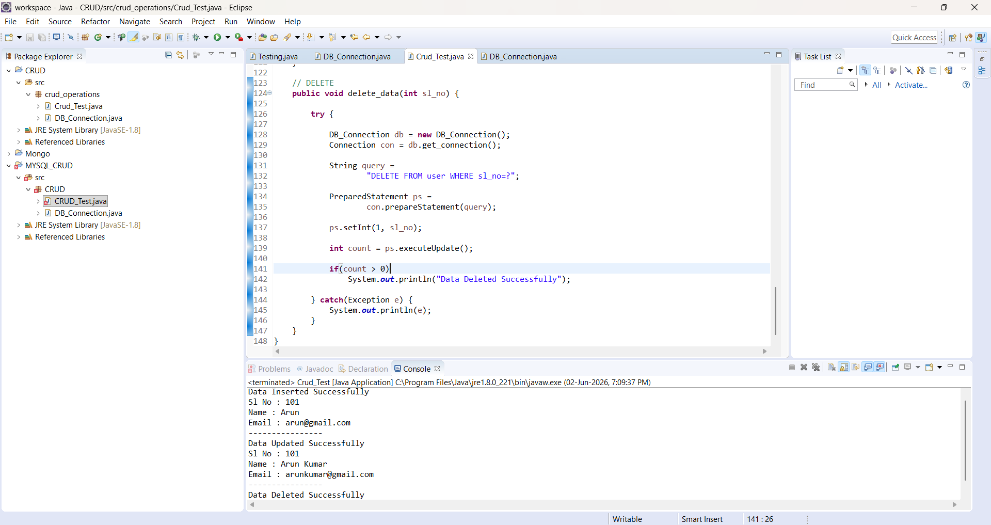

DB_Connection.java

package crud_operations;

import java.sql.Connection;
import java.sql.DriverManager;

public class DB_Connection {

public static void main(String[] args) {

DB_Connection obj_DB_Connection = new DB_Connection();
System.out.println(obj_DB_Connection.get_connection());
}

public Connection get_connection() {

Connection connection = null;

try {

Class.forName("com.mysql.cj.jdbc.Driver");

connection = DriverManager.getConnection(
"jdbc:mysql://localhost:3306/crud",
"root",
"Sid#8749");

} catch (Exception e) {
System.out.println(e);
}

return connection;
}
}

OUTPUT:
com.mysql.cj.jdbc.ConnectionImpl@3d3fcdb0

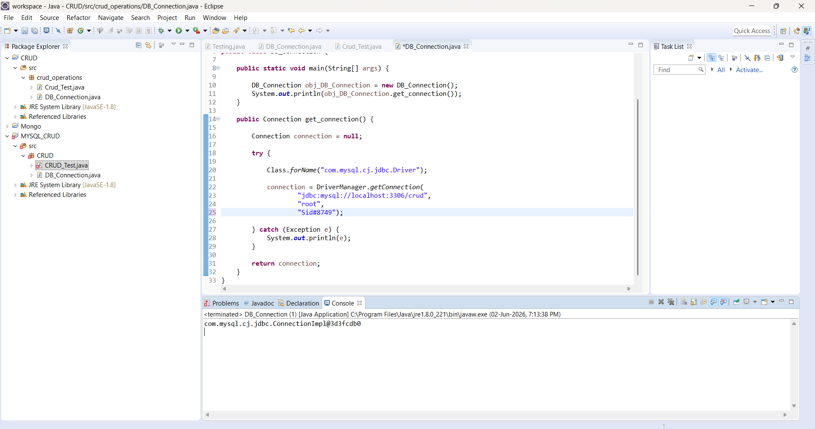
Crud_Test.java

package crud_operations;

import java.sql.Connection;
import java.sql.PreparedStatement;
import java.sql.ResultSet;

public class Crud_Test {

public static void main(String[] args) {

Crud_Test obj = new Crud_Test();

// CREATE
obj.create_data(101, "Arun", "arun@gmail.com");

// READ
obj.read_data(101);

// ALTER TABLE
obj.alter_table();

// TRUNCATE TABLE
obj.truncate_table();
}

public void create_data(int sl_no, String name, String email) {

try {

DB_Connection db = new DB_Connection();
Connection con = db.get_connection();

String query =
"INSERT INTO user(sl_no,name,email) VALUES(?,?,?)";

PreparedStatement ps = con.prepareStatement(query);

ps.setInt(1, sl_no);
ps.setString(2, name);
ps.setString(3, email);

int count = ps.executeUpdate();

if (count > 0) {
System.out.println("Data Inserted Successfully");
}

} catch (Exception e) {
System.out.println(e);
}
}

public void read_data(int sl_no) {

try {

DB_Connection db = new DB_Connection();
Connection con = db.get_connection();

String query =
"SELECT * FROM user WHERE sl_no=?";

PreparedStatement ps = con.prepareStatement(query);

ps.setInt(1, sl_no);

ResultSet rs = ps.executeQuery();

while (rs.next()) {

System.out.println("Sl No : "
+ rs.getInt("sl_no"));

System.out.println("Name : "
+ rs.getString("name"));

System.out.println("Email : "
+ rs.getString("email"));

System.out.println("---------------------");
}

} catch (Exception e) {
System.out.println(e);
}
}

public void alter_table() {

try {

DB_Connection db = new DB_Connection();
Connection con = db.get_connection();

String query =
"alter table user ADD address VARCHAR(20)";
PreparedStatement ps = con.prepareStatement(query);

ps.executeUpdate();

System.out.println("Table Altered Successfully");

} catch (Exception e) {
System.out.println(e);
}
}

public void truncate_table() {

try {

DB_Connection db = new DB_Connection();
Connection con = db.get_connection();

String query =
"TRUNCATE TABLE user";

PreparedStatement ps = con.prepareStatement(query);

ps.executeUpdate();

System.out.println("Table Truncated Successfully");

} catch (Exception e) {
System.out.println(e);
}
}
}

OUTPUT:
Data Inserted Successfully
Sl No : 101
Name : Arun
Email : arun@gmail.com
---------------------
Table Altered Successfully
Table Truncated Successfully
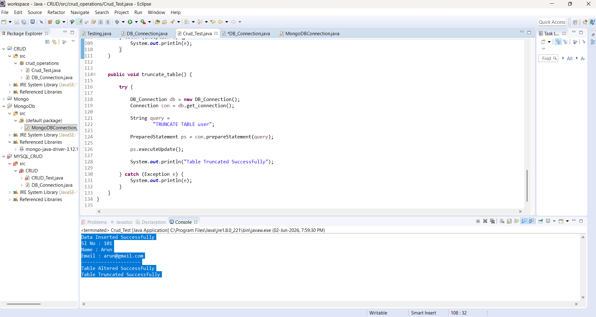
MongoDBConnection.java

import com.mongodb.client.MongoClient;
import com.mongodb.client.MongoClients;
import com.mongodb.client.MongoDatabase;

public class MongoDBConnection {
public static void main(String[] args) {
String connectionString = "mongodb://localhost:27017";

try (MongoClient mongoClient = MongoClients.create(connectionString)) {
MongoDatabase database = mongoClient.getDatabase("testdb");
System.out.println("Connected successfully to MongoDB!");
}
}
}

OUTPUT:
Jun 02, 2026 7:36:28 PM com.mongodb.diagnostics.logging.JULLogger log
INFO: Cluster created with settings {hosts=[localhost:27017], mode=SINGLE, requiredClusterType=UNKNOWN, serverSelectionTimeout='30000 ms', maxWaitQueueSize=500}
Connected successfully to MongoDB!

